1. How to compare two JSON have the same properties without order?
   1. var obj1 = { name: "Person 1", age:5 };
   2. var obj2 = { age:5, name: "Person 1" };

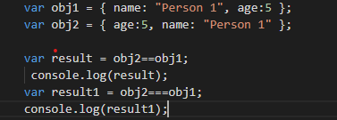

1. Use the rest countries API url -><https://restcountries.eu/rest/v2/all> and display all the country flags in console

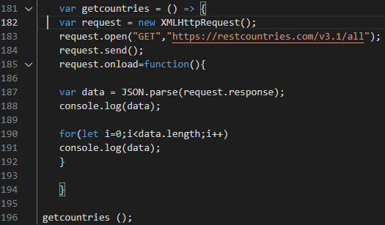

1. Use the same rest countries and print all countries name, region, sub region and population 